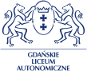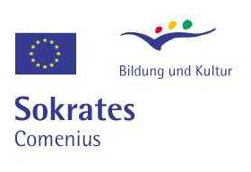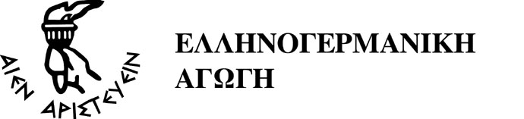

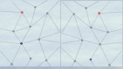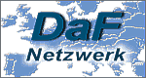

LANGUAGE EDUCATION AND NETWORKING –
A German Language Network as a Contribution to European Integration

DAF-SÜDOST Network
1. Thematic Conference and Contact Seminar, Gdansk, 1 – 3 October 2004

PROGRAMME CONTACT SEMINAR

Through all conference days there will be an exhibit with stands of publishing houses, schools, institutions and projects

Friday, 1 October 2004

Comenius Contact Seminar:
“Bring Europe into your classroom with COMENIUS!”
9.00 – 11.00 | Arrival and registration  Opportunity to build up and equip stands
11.00-11.15 | Welcome by:  Dorota Zagrodzka, Director of Gdanskie Skoly Autonomiczne  Dagmar Schäffer, Co-ordinator of the network „DaF-Südost“, Athens
11.15 – 13.15 | “Join the Experience!”  11.15 – 11.30 Presentation of the network DaF-Südost  11.00 - 11.50 Presentation of the teachers and their schools  11.50 – 12.00 Short coffee break  12.00 – 12.30 Presentation of Comenius 1 school projects  12.30 – 12.50 Presentation of Comenius 2 teacher training projects  12.50 – 13.00 Presentation of other Comenius 3 networks  13.00 – 13.15 Questions and discussion
13. 15 – 13.45 | Short lunch break
13.45 – 14.30 | „The Paper Work!”  Information on COMENIUS Projects and Application Procedures by member of the Socrates National Agency Warsaw Magdalena Wasilenko
14.30 – 15.30 | GERMAN AS A FOREIGN LANGUAGE IN EUROPE  Marketplace with schools and projects from many European countries presenting themselves with stands.  Information and contacts
15.30 – 16. 30 | Workshop  „Networking through Internet“ – web-based forms of cooperation in GFL (Hands-on, with PC)  Dr. Rüdiger Riechert and Andreas Westhofen, IIK, Düsseldorf
16.30 – 17.30 | Development of Projects in Workgroups for Participants of the Contact Seminar
20.00 | Dinner – Reception

Saturday, 2 October 2004

9.30 – 18.30 | Participation in the conference  LANGUAGE EDUCATION AND NETWORKING  (see conference programme)  More information on Comenius and other projects and innovation in the field of German as a Foreign language.  Presentations, workshops, stands.
9.30 – 10.00 | Official Conference Opening  Welcome:  Dorota Zagrodzka, Director of Gdanskie Skoly Autonomiczne  Jean-Michel Boullier, European Commission, DG Education and Culture, Brussels  Detlof von Berg, Consul General of the Federal Rep. of Germany in Gdansk (planned)
10.00 – 11.00 | Key Note Speakers  Halina Stasiak (Univ. of Gdansk): Early Language Learning  Malgorzata Kopka, (German-Polish Youth Foundation, Warsaw): The foreign language as a friendly language
11.30 – 13.00 | Talls and presentations in parallel sessions (see Conference Programme)
14.30 – 14.50 | Talk by Dr.Werner Lich (PAD, Bonn):  Planning COMENIUS?  Ideas on networking activities for schools, teachers, pupils and teacher training institutions within the framework of the European programme Socrates/ Comenius
15.00 – 17.00 | Parallel workshops (see conference programme)
17.00 – 18.30 | GERMAN AS A FOREIGN LANGUAGE IN EUROPE  Marketplace with schools and projects from many European countries presenting themselves with stands.  Information and contacts  Furthermore: Beginners’ Course Polish!!!
Ab 18.30 | Opportunity for a stroll through the beautiful historic center of Gdansk
20.00 | Songs and ballads ending the day

Sunday, 3 October 2004

9.30 – 13.00 | Participation in the conference  LANGUAGE EDUCATION AND NETWORKING  (see conference programme)  More information on Comenius and other projects and innovation in the field of German as a Foreign language.  Presentations, workshops, stands.
9.30 – 11.15 | Parallel workshops (see conference programme)
11.15 - 11.45 | Mini-workshop:  Chat and real-time-communication through Internet for workgroups and projects
12.00 – 13.00 | Round Table Discussion:  Language Education and Networking  – Chances and Challenges  A European panel of experts and educators will discuss.
13.00 | End of Conference
15.00 – 18.00 | Trip to Sopot on the Baltic Sea

